Operating Systems Lab 2026
Assignment Set 1 : Date: 8th January 2026
Submission Deadline 1: 14th January 2026
------------------------------------------------------------------------------------
Objectives: to learn the following:
- Linux installation
- To understand occurrence of race condition in OS
- To learn some useful commands ps, kill, cat, chmod ls, pwd, man etc.
- To learn the use of some basic system calls getpid(), getppid(), fork()
Include suitable header file stdio.h, sys/types.h, stdlib.h, unistd.h etc. as required.
===========================================
A1) Learn the use of ps, kill, cat, chmod, ls, pwd, man etc. commands. Try to be conversant with all the possible options for each command. Try to use man command to know the details of a command, Ex: …..$ man ps to see the help on ps command
==========================================
A2) Execute the balance update code discussed in the class and have a feel of race condition in OS. Create the acc_balance.txt file by executing the init_balance process, Create multiple bal_update processes and let them run simultaneously for a while in background, Showing the anomalous outcome of such simultaneous update in the acc_balance.txt file using cat. Provide the screenshot of the terminal showing the above steps.
A race condition in OS refers to a situation when the outcome of some processing can’t be predicted with certainty.

A3) Write a code where the parent process (say pid 34) should create another child process (say pid 38) by calling fork(). The child process should print “Child running……mypid 38 myparent pid 34 my groupid YY” and the parent process should print “Parent running….. mypid 34 my parents pid XX mygroupid YY”. Before termination both parent & child should print “Bye”.

A4) Write a process that executes just an infinite loop and another process that infinitely calls malloc(). Run both the process in background. Get the terminal snapshot by running suitable ps command to observe the CPU & memory consumption of both the processes. Provide atleast 3 snapshot before the memory hungry gets terminated.
A5) Write a code to where the parent process (say pid 34) should create another child process (say pid 38) by calling fork(). Both of these should run infinte loop after the child creation. Open another terminal and provide the snapshot of the ps command.
- In one run terminate the child process by typing $kill 38 and provide the snapshot of the ps command showing the child as zombie.
- In another run terminate the parent process by typing $kill 34 and provide the snapshot of the ps command showing the child is orphan (init(1) process becomes it’s parent)

A6) Write a utility program which 1st executes the system() call to run ps aux & ps –ef and redirects the output in a text file. Next it opens the text files parses it and reports the number of processes shown, number of Running processes, number of terminals, list pids running CPU intensive processes, list pids of running memory hungry processes.

File dummy.c
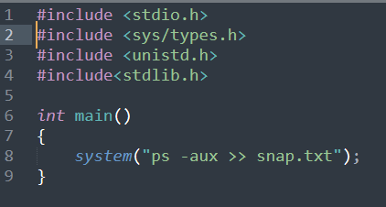

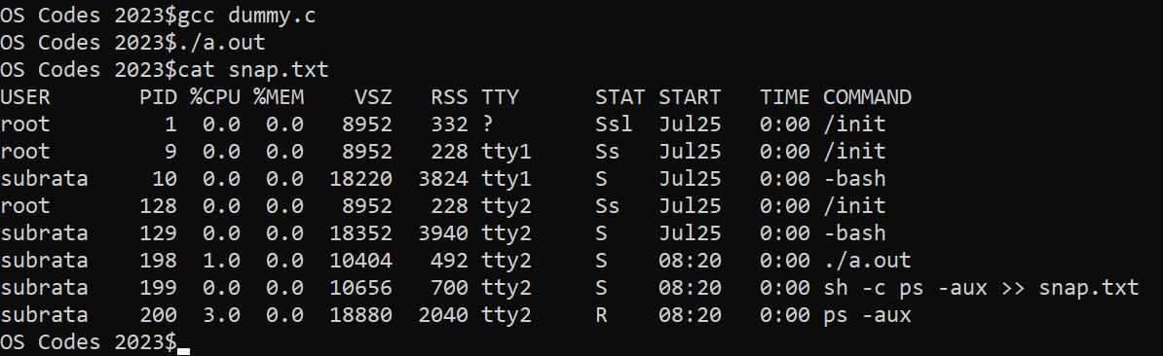

Execute the infinite loop and infinite malloc programs before running the above utility program to report the statistics.
==================================================================
A7) Run the lscpu command ($lscpu) and find out how many cpu cores you are having in your machine. Get the details of the several information displayed using command $man lscpu

